4-8 Ferndell St SOUTH GRANVILLE NSW 2142
PO Box 3107 WETHERILL PARK NSW 2164
Ph: (02) 9632-5000
Fx: (02) 9632-5011
ABN: 18 165 515 257

PRODUCT DATA AND APPLICATION SHEET
PRODUCT NAME L5 Neutral or Active Link

PRODUCT CODE L5, L5R

DESCRIPTION Neutral Link 5 Hole 100amp with Cover
BOX QUANTITY 10 OUTER QUANTITY 100

FEATURES

- 5 Hole Neutral Link with two screws per tunnel;
- 3 tunnels, 5.5mm diameter accommodate 1 x 16 sq mm cable;
- 2 tunnels, 8mm diameter accommodate 1 x 25 sq mm cable
- Dimensions: 65 x 46 x 43 mm

APPLICATIONS
Neutral link 5 hole for service cable switchboards have an outer casing made of a tinted transparent poly-carbonate. The transparent cover enables you to check wiring and locate the sealing screw at a glance. Neutral link 5 pole utilizes a brass bar to link the main to the rest of the circuit. Neutral link 5 pole are ideal for both commercial and industrial use in switchboards as it can take cables of up to 25mm in size. The sealing screw with brass insert, resists stripping.

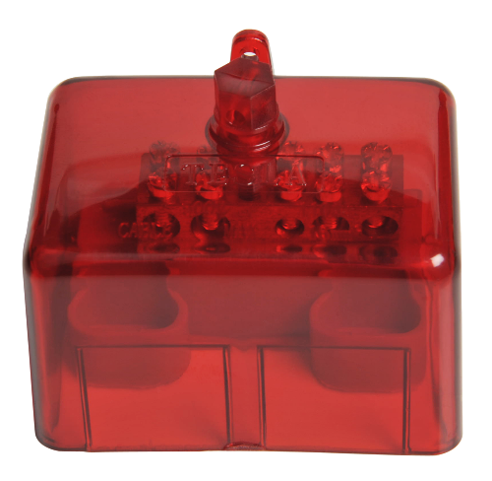
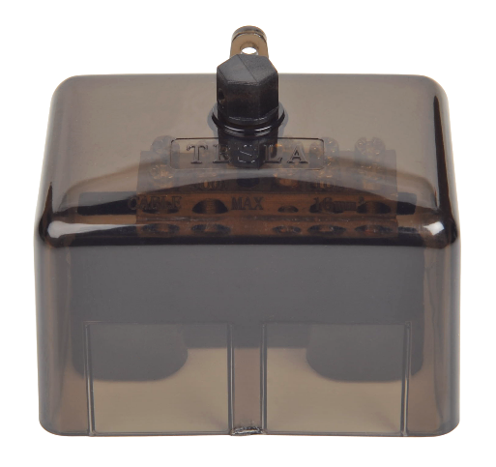

TESLA Electrical Components –Sept17 L5(R)

